To the Association of Dental Technicians and Engineers of Dental Prosthetics of Slovenia

Belgium, 12 August 2010

Dear Madams, Sirs,

The new elected FEPPD board is organizing its first meeting on the 20th of August in Portoroz, Slovenia.

As the FEPPD wants to intensify its relations with its member countries, candidate countries and other interesting organisations, we would be honoured if a delegate of your organisation could join our meeting.

Therefore, we would like to invite the organisation to participateat this first council meeting to discuss our mutual relationship and cooperation a.w.a. our future responsibilities vis-à-vis the dental technicians throughout Europe.

We propose to meet you at:
Hotel Marko
Obala 28
6320 Portoroz
Slovenia
on the 20th of August 2010 at 15.30h.

The board wants to welcome you as well at our dinner after the meeting at 20.00h.

Please let us know with how many people you will participate in our meeting and dinner and do not hesitate to contact us if there are any questions. (Evy Mentens: evy.mentens@feppd.eu; Telephone number: 0032 478 75 49 99)

We look forward to your prompt reply.

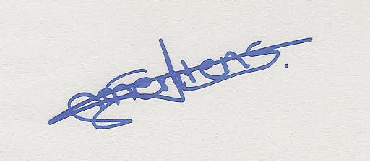
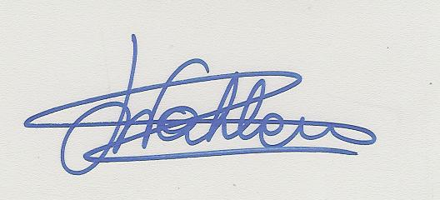
Yours sincerely

Evy Mentens Hilde Wahlen
Office Manager President

